Nama : Erlangga Rizal Mahendra

NIM : 2440101704

Mo_5

1. Display all female staff’s data from MsStaff

**(select)**

--- 1 Display All female staff from MsStaff

USE OOVEO_Salon

SELECT * FROM MsStaff

WHERE

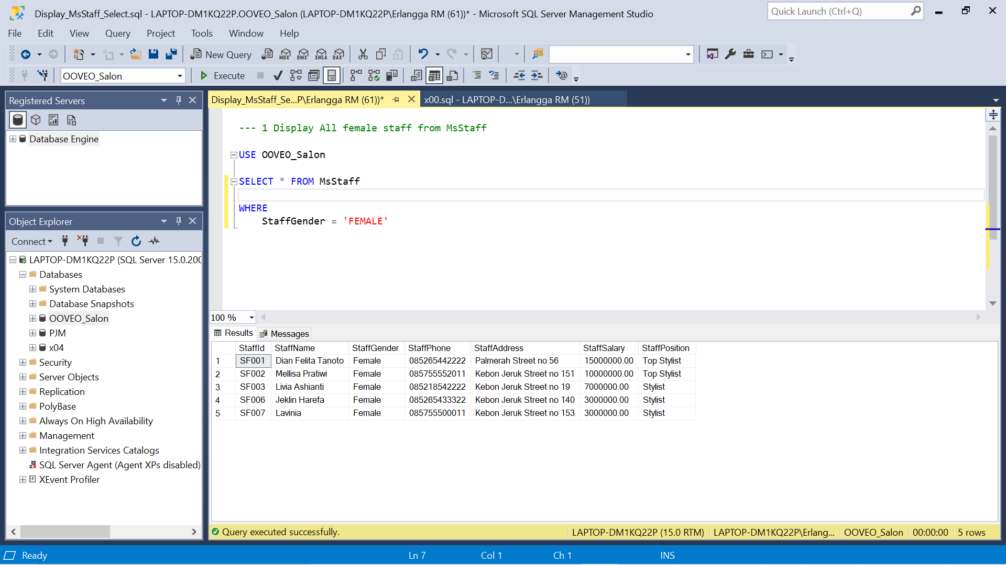 StaffGender = 'FEMALE'

1. Display StaffName, and StaffSalary(obtained by adding ‘Rp.’ In front of StaffSalary) for every staff whose name contains ‘m’ character and has salary more than or equal to 10000000.

(**cast**, **like**)

--- 2 Disp StaffName & StaffSalary by add Rp

USE OOVEO_Salon

SELECT

StaffName,

'Rp. ' + CAST(CAST(StaffSalary AS decimal (20, 2)) AS VARCHAR) AS StaffSalary

FROM

MsStaff

WHERE

StaffName LIKE '%m%'

AND

StaffSalary >= 10000000

1. Display TreatmentName, and Price for every treatment which type is 'message / spa' or 'beauty care'.

(**in**)

--- 3 Display treatmentName & price SPA

USE OOVEO_Salon

SELECT

TreatmentName,Price

FROM

MsTreatment AS Mt

JOIN

MsTreatmentType AS Mtt

ON

Mt.TreatmentTypeId = Mtt.TreatmentTypeId

WHERE

Mtt.TreatmentTypeName

IN

(

'Message / Spa',

'Beauty Care'

)

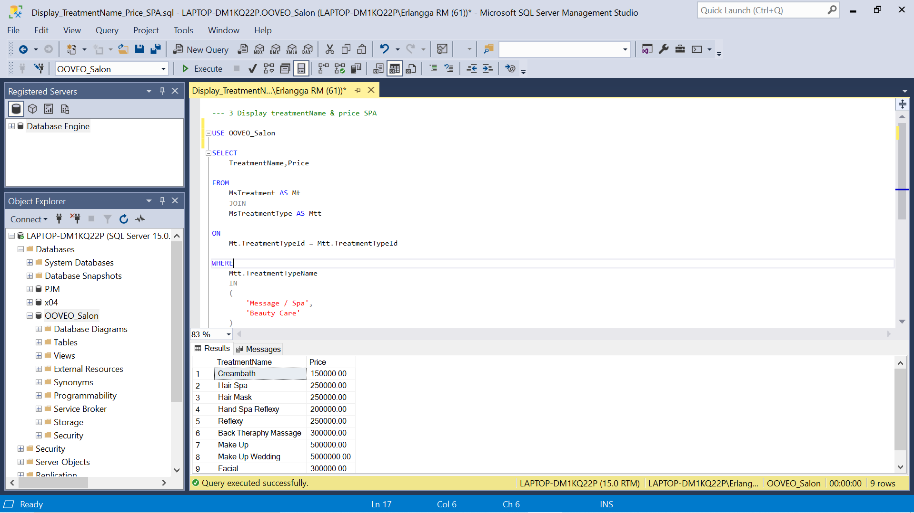

1. Display StaffName, StaffPosition, and TransactionDate (obtained from TransactionDate in Mon dd,yyyy format) for every staff who has salary between 7000000 and 10000000.

(**convert**, **between**)

--- 4 Display StaffName,Position & TransactionDate

USE OOVEO_Salon

SELECT

StaffName,StaffPosition,

CONVERT(VARCHAR,hss.TransactionDate, 107) AS TransactionDate

FROM

MsStaff AS Ms

JOIN

HeaderSalonServices AS Hss

ON

Ms.StaffId = Hss.StaffId

WHERE

StaffSalary BETWEEN 7000000 AND 10000000

1. Display Name (obtained by taking the first character of customer’s name until character before space), Gender (obtained from first character of customer’s gender), and PaymentType for every transaction that is paid by ‘Debit’.

(**substring**, **charindex**, **left**)

--- 5 Display First Character using substring

USE OOVEO_Salon

SELECT

SUBSTRING(CustomerName, 1 , CHARINDEX(' ',CustomerName + ' ')) AS name,

LEFT

(CustomerGender, 1) AS Gender,

Hss.PaymentType

FROM

MsCustomer AS Mc

JOIN

HeaderSalonServices AS Hss

ON

Mc.CustomerId = Hss.CustomerId

WHERE

Hss.PaymentType LIKE 'D%'

1. Display Initial (obtained from first character of customer’s name and followed by first character of customer’s last name in uppercase format), and Day (obtained from the day when transaction happened ) for every transaction which the day difference with 24th December 2012 is less than 3 days.

(**upper**, **left**, **substring**, **charindex**, **datename**, **weekday**, **datediff**, **day**)

--- 6 Display Initial using UPPER case

USE OOVEO_Salon

SELECT

UPPER(LEFT(CustomerName, 1)

+

SUBSTRING(CustomerName, CHARINDEX(' ', CustomerName) + 1, 1)) AS Initial,

DATENAME(WEEKDAY,Hss.TransactionDate) AS Day

FROM

MsCustomer AS Mc

JOIN

HeaderSalonServices AS Hss

ON

Mc.CustomerId = Hss.CustomerId

WHERE

DATEDIFF(DAY, Hss.TransactionDate, '2012-12-24') < 3

1. Display TransactionDate, and CustomerName (obtained by taking the character after space until the last character in CustomerName) for every customer whose name contains space and did the transaction on Saturday.

(**right**, **charindex**, **reverse**, **like**, **datename**, **weekday**)

--- 7 Display TransactionDate & CustomerName obtaining Last Character

USE OOVEO_Salon

SELECT

Hss.TransactionDate,

RIGHT

(CustomerName,CHARINDEX(' ',REVERSE(CustomerName)) AS CustomerName)

FROM

MsCustomer AS Mc

JOIN

HeaderSalonServices AS Hss

ON

Mc.CustomerId = Hss.CustomerId

WHERE

CustomerName LIKE '% %'

AND

DATENAME(WEEKDAY,Hss.TransactionDate) = 'Saturday'

1. Display StaffName, CustomerName, CustomerPhone (obtained from customer’s phone by replacing ‘0’ with ‘+62’), and CustomerAddress for every customer whose name contains vowel character and handled by staff whose name contains at least 3 words.

(**replace**, **like**)

---8 Display StaffName, CustomerName, CustomerPhone

USE OOVEO_Salon

SELECT

StaffName,Mc.CustomerName,

REPLACE(CustomerPhone, '08', '+628') AS CustomerPhone,

Mc.CustomerAddress

FROM

MsStaff AS Ms

JOIN

HeaderSalonServices AS Hss

ON

Ms.StaffId = Hss.StaffId

JOIN

MsCustomer AS Mc

ON

Mc.CustomerId = Hss.CustomerI

WHERE

Mc.CustomerName LIKE '%[A,I,U,E,O]%'

AND

Ms.StaffName LIKE '% % %'

1. Display StaffName, TreatmentName, and Term of Transaction (obtained from the day difference between transactionDate and 24th December 2012) for every treatment which name is more than 20 characters or contains more than one word.

(**datediff**, **day**, **len**, **like**)

--- 9 Display StaffName, TreatmentName, and Term of Transaction

USE OOVEO_Salon

SELECT

StaffName,Mt.TreatmentName,

DATEDIFF(DAY, Hss.TransactionDate,'2012-12-24') AS "Term of Transaction"

FROM

MsStaff AS Ms

JOIN

HeaderSalonServices AS Hss

ON

Ms.StaffId = Hss.StaffId

JOIN

DetailSalonServices AS Dss

ON

Dss.TransactionId = Hss.TransactionId

JOIN

MsTreatment AS Mt

ON

Mt.TreatmentId = Dss.TreatmentId

WHERE

LEN(Mt.TreatmentName) > 20

OR

Mt.TreatmentName LIKE '% %'

1. Display TransactionDate, CustomerName, TreatmentName, Discount (obtainedby changing Price data type into int and multiply it by 20%), and PaymentType for every transaction which happened on 22th day.

(**cast**, **day**)

---10 Display TransactionDate, CustomerName, TreatmentName, Discount

USE OOVEO_Salon

SELECT

Hss.TransactionDate,Mc.CustomerName,Mt.TreatmentName,

CAST(Mt.Price * 0.2 AS INT) AS Discount,

Hss.PaymentType

FROM

MsCustomer AS Mc

JOIN

HeaderSalonServices AS Hss

ON

Mc.CustomerId = Hss.CustomerId

JOIN

DetailSalonServices AS Dss

ON

Dss.TransactionId = Hss.TransactionId

JOIN

MsTreatment AS Mt

ON

Mt.TreatmentId = Dss.TreatmentId

WHERE

DAY(Hss.TransactionDate) = '22'

